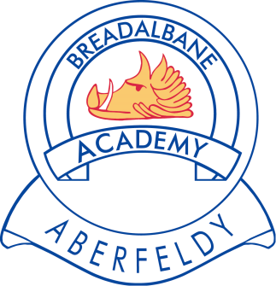

The next School Fund meeting will be held on 25th May 2018

Please direct any queries or requests, in writing, to Mrs K Leighton, School Fund Secretary c/o Breadalbane Academy

